Project Title: A Specialized Anterior Cervical Corpectomy Plate

Authors: Jessica Brisbin, Rob Hartman, Laura Killian, and Ian Smith

Executive summary
Neck pain is a very common condition; in fact, 50% of the population has evidence of degenerative changes in their cervical spine by age 50¹. In severe cases of cervical degeneration with bony compression of the nerve roots or spinal cord, a surgical procedure called a corpectomy is often used to decompress the neural tissue. This technique involves the removal of the degenerated vertebral bodies and discs in the cervical spine. Then, a graft typically drawn from a patient’s fibula is inserted into the hollowed out cervical space and fitted into the adjacent levels. Lastly, a plate is placed over the anterior face of the spine and graft to stabilize the spinal column while the graft fuses.
Some problems with anterior graft stability include graft subsidence and screw loosening from compression, distal end kick-out during neck extension, and limited torsional resistance. The failure mechanisms can cause acute construct failure and graft dislodgement or chronic instability and reoccurring neuropathic symptoms. There are various operational techniques used for the specific purpose of addressing these failure mechanisms. They include three surgical techniques: (1) graft insertion without anterior plating, (2) graft insertion and anterior plate attachment with screws driven into the graft, and (3) superior and inferior body fixation without intermediate level fixation. Each of these techniques may include posterior fixation to achieve stability while the bone construct fuses². However, the use of anterior and posterior surgery increases operation length and complexity because the patient must be flipped over intra-operatively from supine to prone positions to permit posterior cervical access, sedation time increases, damage occurs to the posterior musculature, and risk of infection increases. The violation of the posterior musculature can extend the post-operative recovery period.
The proposed procedure using the specialized corpectomy plate involves only anterior fixation. If anterior-only stability can be achieved, it resolves problems with current plating methods because it provides screw fixation at each vertebral instrumented level, allows wider screw placement, and avoids penetrating the graft due to lateral fixation. To fulfill clinician’s expectations, this device will achieve sufficient stability, as described by White and Panjabi⁸, using an anterior-only procedure, reducing the failure rate due to distal end kick-out and torsion. The device will be simple to use and compatible with standard operating room equipment for fusion operations. In particular, the prototype will be designed to interface with Medtronic’s cervical screws and driver. Therefore, this device should reduce the cost of the procedure through decreased surgery length, and it should reduce the overall cost of health care by decreasing the frequency of revisional surgeries.
A 510(k) regulatory route will be pursued because of the design plate’s similarity to other anterior plates in terms of form, material, application, and function. Should the added expectations from the lateral wings preclude the claims of equivalency, the premarket approval (PMA) route will be anticipated, which requires an investigational device exemption (IDE) for human testing. The efficacy of the plate must be proven prior to its market release, which will require clinical testing that compares the novel plate to current anterior-only and anterior-and-posterior operations. As indicated by Class II Special Controls Guidance Document: Intervertebral Body Fusion Device³ and Spinal System 510(k)⁴, the device will be defined as a Class II device.
The novel plate was modeled in a general sense after a Medtronic’s Atlantis©; therefore, the plate was made to be compatible with all of Medtronic’s surgical equipment. However, all features, such as intermediate-level fixation, wider fixation, viewing windows, screw-plate interface variability, and a screw back-out mechanism were optimized and redesigned for the corpectomy specific application. Finite element analysis (FEA) using COSMOSWorks (SolidWorks Corp., Concord, MA) was conducted to analyze the stress distributions for a Ti-alloy (Ti-6Al4V) and nickel-coated ceramic (SLArmorTM 30% metal volume) plate in cyclic and static bending and axial loading. The goal of FEA is (1) to supplement mechanical testing by predicting stresses in the plate made of SLArmorTM prototype and (2) to simulate in-vivo loading conditions, which are unachievable using cadaveric testing. Mechanical testing was performed on porcine cadaveric specimens to compare the stability of a traditional anterior plate to the specialized corpectomy plate. Intact load-displacement behavior in bending and creep behavior in compression were determined using a robot-based spine testing system. A corpectomy was simulated on two porcine cervical spines (C3-6). Post-operative mechanical testing repeated intact testing to elucidate differences associated with each plate. Load-to-failure tests were performed in axial compression on the instrumented specimens on an axial testing machine (ATM).
In 1999, there were over 500,000 spinal procedures performed in the United States, and of these, 11,802 were cervical corpectomies⁵. Based on average hardware costs of $7500, the annual corpectomy market exceeds $88.5M. With neck pain on the rise in the world population, the number of spinal procedures and corpectomies is increasing accordingly. Bearing this in mind, the hope is to prove the technical feasibility of and demand for our device, and sell it to Medtronic, whose technology has served as a template in prototype development and who will be able to facilitate the PMA processes and the transition from the PMA process to distribution to hospital systems across the country. Surgeons will be the primary user of the device, but hospital systems will negotiate the contracts. The projected cost of this procedure will be approximately $7500 for the plate, screws, and auxiliary equipment⁵. However, the titanium-alloy plate being designed will cost approximately $3000-$4000. This cost is higher than typical anterior plates⁶; the low volume and increased manufacturing complexity raise the price. However, the stated benefits of the design aim to reduce the overall cost of corpectomy procedures.

Problem Description
Myelopathy and radiculopathy, impingement of the spinal cord and nerve roots, respectively, are conditions that typically warrant decompressive spinal surgery. In severe cases where compression of the neural tissue results from bony changes in the vertebral bodies, cervical corpectomies are often performed⁷. The center portion of the pathologic vertebra are removed to form a void (14-22 mm wide) exposing the dura mater. A graft from the fibula or iliac crest is formed to fit the void and penetrate the adjacent endplates. It is inserted in the trough with the expectation of bony fusion over several months. Current surgical practices include: (1) graft insertion without anterior plating, (2) graft insertion with anterior plate attachment with screws driven into the graft, and (3) graft insertion with anterior plate fixation with superior and inferior body fixation without intermediate level fixation. Common mechanical problems from this operation include failure in compression of extension due to subsidence of the graft and screw loosening. While the loosening can result in chronic instability, it can also cause acute instability. The screws can translate through the vertebral body causing the distal end of the plate to detach from the inferior spine. The frequency of this occurrence increases with the number of levels involved because the high moment experienced by the plate in extension increase with plate length⁷. Additionally, the narrow geometry of anterior plates lends the construct to torsional instability and potential disjuncture. Damage to cervical organs and surrounding muscle and soft tissue follows plate loosening or detachment. Immediate revisionary surgery is typically needed. Many surgeons add posterior fusion to adequately stabilize the instrumented levels and avoid these sequelae. However, a posterior operation more than doubles the length of the procedure and increases a patients risk for complications and postoperative recovery time.
The added costs and risks of longer, more complex surgery and of mechanical problems with current anterior plates and grafts warrant an improved method of anterior fusion that would reduce the need for revisions and preclude the need for posterior stabilization. The proposed solution is an anterior plate that will reduce the frequency of distal end kick-out and torsional failure while providing sufficient stability to allow an anterior-only approach to reduce operation risks and duration. By reducing the operation time and the frequency of emergency revision surgeries, the proposed anterior plate would cut surgical costs for the hospital systems. Spine surgeons are the intended end-user of the product. Surgeons would appreciate the reduced surgery time and reduced risks by avoiding posterior operations. Patients would benefit from reduced cost, quicker recovery time, and shorter surgeries. Finally, hospital system purchasers, who negotiate the contracts for spinal fusion equipment used in corpectomies, would benefit from reduced operation time and fewer cases of revisionary surgery.

Design Objective
The design of the proposed device intends to increase plate-graft-bone stability and to allow an anterior-only surgical approach. Construct stability will be improved by increasing the number of levels of fixation and by placing intermediate screw locations laterally. Current applications simply screw the plate to the superior and inferior vertebral bodies adjacent to the graft, employ intermediate fixation by screwing the plate into the graft at each intervening level, or avoid the use of anterior plating altogether. First, the corpectomy specific plate design has screw holes that extend laterally on wing-like projections around the vertebral body in the intermediate levels. Fixation at intermediate levels distributes the extension moment more evenly throughout the plate, reducing the probability of distal end kick-out. Second, the wider hole placement allows screws to penetrate the remaining bone of the vertebral body, achieving fixation at each intermediate level but not weakening the bone graft with screw holes. The lateral fixation points increase the moment of inertia about the long axis of the spine, increasing torsional resistance. Combining these improvements should enhance construct stability such that posterior fusion, which is applied at every level in the lateral portion of the posterior structures, becomes unnecessary.

Prototype
Model development of the plate was completed using SolidWorks (SolidWorks Corp., Concord, MA) computer aided engineering (CAE) software suite. First, Medtronic’s Atlantis©, an anterior cervical fusion plate widely used among spine surgeons today, was modeled in SolidWorks. The plate dimensions were derived from micrometer and coordinate measuring machine (CMM) measurements. The reverse-engineered Atlantis© plate was used as a control plate for comparisons between the novel plate and traditional plate in finite element analysis (FEA) and mechanical testing of fabricated plates. The traditional plate, depicted in Figure 1 of Appendix A, also served as a basis from which the design plate was created. The length and thickness of the plate were kept constant between the plates. The differences between the two designs are illustrated in Figures 1-4. Wings were extended outward in the intermediate portion of the plate to provide screw attachment sites at the remaining good, lateral bone. The inner width was kept the same. A back-out prevention mechanism similar to that of the Atlantis© plate was utilized on the wings. The wings were curved and recessed to better fit the contour of cervical vertebral bodies.
Both plates were sized to fit a saw-bone model of a human cervical spine, whose dimensions were measured using a micrometer. Refer to Appendix A-Figure 5 for a drawing of the plate. These dimensions include the vertebral radius, vertebral width, intervertebral distances, and vertebral body height. The plate dimensions (overall length, overall width, wing curvature, wing width, inter-wing spacing, and screw length) were fitted to the model’s dimensions. Customized plate sizing was performed because it is impractical to fabricate the full gamut of plate sizes typically produced by spinal implant manufacturers. Porcine cervical spines were used for comparative mechanical testing of the plates because of the similarity in interbody spacing between human and porcine anatomy. Fifty-pound pigs were identified as likely matches to the saw-bone model sizing. Following dissection of two pig spines, this expectation was fulfilled.
The final design plate morphology was the result of a series of ten design iterations that included feedback from finite element analysis, surgeons, machinists, and engineers. Analysis of stress distributions under static and cyclic loading (see Verification section) permitted adjustment of plate features like profile thickness, window width, and plate curvature. At an intermediate stage, a stereolithographic (SLA) prototype was fabricated to provide surgeons with a tangible representation of design ideas and facilitate constructive feedback (see Appendix A-Fig 6). Following conversations with machinists and engineers and additional FEA, the final design was fabricated from a Ni-coated ceramic SLA material (SLArmorTM - 30% metal volume). Both the control plate and the design plate were made from SLArmorTM for comparative mechanical testing on the porcine spines. SLArmorTM has an elastic modulus of 42GPa, and a tensile strength of 200MPa. The structural integrity of the combination of Ni and ceramic was sufficient for the robotic mechanical testing; however, it caused plate buckling in axial compression not expected to occur with a metal alloy.

Risk Analysis
As with all spinal surgery devices, there are multiple failure methods presented with the novel design. These failures can cause severe risks to the patient. Problems can be grouped in two types of component failures: the plate or the screws.
Failure of the plate may result from buckling in compression or bending in extensive moments or torsional loads. Failure in axial compression are unlikely when using a Ti-alloy, however, they are possible due to the curvature of the plate introducing the probability for buckling. Plate failure could introduce chronic instability or acute disjuncture, which would damage the cervical organs and musculature, most notably the vertebral arteries. The likelihood of plate yielding is quite low given the yield strength of the Ti-alloy (1.05 GPa). However, these failure mechanisms proved that they were possible with SLArmorTM selected for prototype testing.
The redesign of the wings brings two significant failure modes, improper vertical positioning and lateral sizing of the wings. These errors can cause damage to adjacent levels and to the spinal soft tissue. If improperly sized, the screws in the wings could damage the vertebral arteries, provoking immediate, life-saving measures.
The final hazard introduced by the plate is the back-out mechanism. If this fails, the screws could loosen from the bone, allowing the plate to pull off the bone. The construct would become unstable, causing damage to cervical organs and requiring revisionary surgery.
Potential screw failure mechanisms also introduce several serious clinical risks. The connection between the plate and vertebral bodies must be rigid. Otherwise, chronic instability may lead to fusion failure. Screw angles that are too large (unacceptable tolerances) for rotating screws in the proximal end of the plate might allow screws to shift in the bone beyond the intention of the surgeon. This could cause damage to the vertebral bodies or non-union. If the screws do not lock into the plate or if the screws shear due to axial or torsional loading, the surrounding tissues could be damaged and revisionary surgery would be warranted.

Verification and Validation
Verification consisted primarily of quantifying load-displacement behavior in mechanical construct testing and analyzing stresses in FEA. The test plan for and execution of in-vitro mechanical testing and FEA are described below.

Verification
- Construct testing
  - Intact testing
      - Two intact porcine specimens were characterized by mechanical testing (described below) of the un-instrumented specimens. Flexion/extension and axial rotation range-of-motion (ROM) were determined for each specimen on a serial-linkage robot (a robot-based spine testing system). The ROM and creep behavior of the intact specimens in response to cyclic compressive loads were also characterized on the robot-based testing system.
      - Cyclic axial testing using the spine testing system
    - 150 cycles of 20N were applied quasi-statically in (C) to both constructs.
    - The time dependent displacement of the specimen were also measured.
2. Robotic load-displacement testing in flexion/extension and axial rotation
i. 2 Nm, adaptive-displacement (with load feedback and thresholding) testing were applied for both motions. Two cycles of preconditioning preceded the recorded ROM path.
ii. The quasi-static load-displacement response of the intact specimen were determined.
  - Surgery
    - Following intact testing, a corpectomy was performed on each specimen. A control plate similar to Medtronic’s Atlantis© was used on one spine, and the design (experimental) plate was used on the other. The ability of the plate to appropriately fit the porcine specimen was assessed.
  - Instrumented testing
    - Following the operation, both constructs (the specimen-control plate and the specimen-design plate) were tested in similar manner to intact testing.
      - Cyclic axial testing using the spine testing system
i. 130 cycles of 20N were applied quasi-statically in (C) to both constructs. The change in time-dependent displacement in response to cyclic loading between the two constructs was compared.
ii. The results of intact and instrumented cyclic compression are depicted in Appendix B-Figures 1 and 2. The control plate reduced displacement by approximately 0.5 mm across the 130 cycles. Conversely, the design plate did not reduce displacement in early cycles but reduced displacement by approximately 0.8mm at higher cycle numbers. The creep behavior did not change in the control case while it did change for the design plate.
2. Robotic load-displacement testing in flexion/extension and axial rotation.
i. 2 Nm hybrid-control testing was applied for both motions (as in intact testing).
a. Flexion/Extension results: Figures 3 and 4 illustrate the load-displacement results in flexion/extension for both cases. Figure 5 demonstrates the percent reduction of ROM for both plates for both positive and negative moments of flexion/extension.
  - Axial Rotation: Figures 6 and 7 illustrate the load-displacement results in flexion/extension for both cases. Figure 8 demonstrates the percent reduction of ROM for both plates for both positive and negative moments of flexion/extension. Load-to-failure testing was conducted in compression on the ATM.
          - Failure in compression was achieved because attaining failure in extension (the most physiologically relevant failure mechanism) is impossible on the spine testing system, due to load restrictions. Compression failure is secondary to extension in regards to pathophysiological relevance.
- Each specimen was mounted in the ATM using proven fixation methods similar to those used in the robot-based spine testing system. Beginning with no applied load, compressive loads will be increased in with a head-displacement rate of 0.5mm/s.
- Both plates broke prior to apparent specimen damage. The metal-coated ceramic plates buckled. The control plate simply buckled; the design plate’s intermediate screws pulled out of the bone prior to fracture. The difference in the failure mechanisms and the load values at failure are illustrated in Figure 9.
- COSMOS testing (Plate testing)
- Plate testing was simulated in COSMOSWorks (Finite Element Analysis (FEA)). Testing, in part, simulated the material and methods of in-vitro mechanical testing; i.e., the Ni-plated ceramic defined the material (SLArmorTM), and loading values and patterns imitated those from robotic testing. Stress distributions were analyzed. Nevertheless, because model validation could not be achieved with mechanical testing, the utility of the FEA results is in comparison, i.e. looking at difference between the control plate and the design plate under similar loading conditions. Thus for each simulation described, the results are compared between the two plates to glean relevant information.
  - Extension
    - All screw holes were fixed. A distributed force perpendicular to the inferior holes, simulating the clinically observed, “distal-end pullout,” were applied ranging from 0N at the superior end to 70N at the inferior end. The plate deformation and stress distribution were analyzed statically and the factor of safety (FOS) was analyzed under cyclic loading.
      - Static:
        - ≥2Nm (similar to robotic testing) was approximated by applying a distributed 70N force to a plate defined with the material properties of SLArmorTM (see Figure 10).
        - ≥15 Nm, reflecting damaging in-vivo loads, was approximated by applying a distributed 500N force to a plate defined as Ti-6Al4V (see Figure 11)^{8,9}.
      - Cyclic:
        - 1000 cycles of 2Nm (SLArmorTM) were applied to the plate to extrapolate information about the plates’ behavior in repeated loading situations (see Figure 12)¹⁰.

  - Compression
    - All screw holes were fixed. A force tangent to the curve of the plate, simulating the clinically observed, “subsidence,” was applied. The plate deformation and stress distribution were analyzed statically and the factor of safety (FOS) was analyzed under cyclic loading.
      - Static:
        - 20N was applied. Although plate displacement with respect to the cervical spine cannot be simulated simply in FEA (screw-specimen interactions), plate deformations and stresses were analyzed assuming rigid fixation to the spine, reflecting stresses higher than predicted in-situ. Applying 20N of compression to either plate caused negligible stresses to develop¹⁰.
        - 2500 N, determined to exceed damaging in-vivo loads, was approximated and applied directly to the plate to simulate a “worst case” type of loading (see Figure 13)^{9,11}.
      - Cyclic:
        - 1000 cycles of 20N were applied to the plate to parallel robotic compressive testing (see Figure 14)¹⁰.

Validation
- The performing spine surgeon evaluated the plate and scored it with respect to design features and compare it with existing plates. A survey was developed and completed for this task (Refer to Table 1).
- A spine surgeon simulated a surgery using a porcine cervical spine using existing corpectomy methods and equipment (Medtronic Atlantis) as well as the new plate in conjunction with existing equipment. Following surgery, the stability of the two constructs was compared through a surgeon evaluation (White & Panjabi). This addresses:
  - Perceived safety of the procedure: worse than other plates
  - Perceived stability of the construct: not sure
  - Ability to perform modified procedure: able to do so
  - Compatibility with existing equipment: compatible
  - Time of the procedure (comparison): took longer than normal procedures
  - Perceived stability (t=0), (t>0): not sure
- Despite the lack of enthusiasm on the part of the performing surgeon, the leading cervical spine surgeon at UPMC, Dr. James Kang, expressed interest in advancing this work and trying one of the plates, provided additional mechanical research is done, in actual patients.
Patent Search
By the early 1980’s, traditional means of affixing metal plates to fractured bone segments by passing screws through the bone was an accepted and widely used practice in orthopedics. Metal plates were fixed to separate fragments of bone fractures to immobilize and hold together the broken fragments so that the bone would heal properly. In early plates, screws simply passed through the pre-made holes in the plate without a positive mechanical lock between the screws and the plate. Therefore, displacement between the screws and the plate occurred frequently. Screws would also ‘work loose’ and displacement from the bone fragments and through the plate screw holes. Both types of displacements, resulting from subsidence (post-surgical bone settling), would result in improper immobilization and possible revisionary surgery¹².
In May of 1985, Caspar et al. received the first patent for a plate specifically designed to obtain cervical spine stability. The plate was trapezoidal in shaped with divergent longitudinal edges. This provided the plate with two adjacent rows or elongated slots for its screws, making the orientation of the longitudinal axes of the slots in both of these rows divergent like the longitudinal edges of the plate itself. As a result, the plate provided a good fit for pieces of bone that are likewise trapezoidal or divergent in shape. The design of the screw holes as slots permitted a large range of variation with respect to screw positioning, providing latitude for the anatomical conditions of a given case. The diverging direction of the two rows of screw holes also allowed for exceptionally secure fixation of the plate in its longitudinal direction¹³.
Lowery et al. found a need for a cervical plating system which minimized the intrusion into the patient and reduced trauma to the surrounding tissue. They also sought a system that allowed for easy access to drill and tap the cervical vertebrae with little room for error in positioning the fixation screws. In 1994 they achieved this by designing a plate that included a lower surface adapted to engage the anterior portion of the vertebrae. A pair of screw bores were defined at both the top and bottom ends between the lower and upper surfaces and displaced from each other transversely to the longitudinal axis of the plate. The pair of screw bores had centerlines that diverged relative to each other and relative to the lower surface of the plate. The system also included several bone engaging screws, one for each of the pair of screw driven in at both the top and bottom edges. Each of the screws included an elongated shank with bone engaging threads and an enlarged head for engaging a corresponding screw bore when the shank extends throughout. The divergent screws achieved an objective of the plated to minimize the intrusion and trauma to tissue surrounding the implantation site by diverging below the plate and converging above the plate so that two screws could have been inserted through the bores from essentially the same location. Furthermore, the lower surface of the plate was curved transverse to the longitudinal axis to conform to the anterior surface of a vertebra and was curved along the longitudinal axis to conform to the lordotic curvature between vertebrae. To enhance the versatility of the spinal fixation system, the fixation plate included a number of elongated slots defined in the plate between the lower and upper surfaces disposed longitudinally between the number of screw bores at both ends of the plate. Each of the number of elongated slots had mutually parallel slot axes along their length that intersect the longitudinal axis of the plate at an acute angle¹⁴.
Recent developments in cervical plates have targeted reducing the effects of subsidence on long-term construct stability. Metronic’s Premier, Stryker’s Reflex Hybrid, Depuy’s Eagle and Sklyine, and Zimmer’s Trinica all incorporate screws that can toggle within a fixed arc. New strategies also include translating plates that move with respect to fixed screw locations. Both strategies allow for the plate and screws to move as subsidence occurs in an effort to reduce the stress placed on the construct in bending moments. However, a plurality of surgeons disagrees with the philosophy of permitting motion in a fusion device. An alternative school of thought espouses the idea that improved solidity of fusion will reduce subsidence. The proposed novel device adheres to the latter paradigm².

Anticipated Regulatory Pathway
The FDA regulates all medical devices marketed in the United States; thus, before the plate can be sold or distributed for use, it must first obtain FDA approval. Section 860 of the 21 CFR describes the medical device classification procedures. Similar plates such as Medtronic’s Atlantis, Premier, and Zephir, are considered Class II devices. The plate would also be a Class II device. Because the design plate has similar form, material, application, and function with respect to existing anterior plates, a 510(k) regulatory route will be pursued. Relevant FDA guidances include Class II Special Controls Guidance Document: Intervertebral Body Fusion Device¹⁵ and Spinal System 510(k)s⁴.
Despite claims of equivalency, it is conceivable that the new design features and hazards introduced by the plate will require pre-market clinical trials. Thus, preparation for obtaining an investigational device exemption (IDE) to facilitate the pre-market approval (PMA) regulatory route has been made. It is understood that the process requires a description of the novel plate—its overall specifications and specific indications of use. Additionally, all mechanical testing, wear testing, animal trials, and human trials involving the plate and the motivating rationale for each must be considered and submitted. Furthermore, sterilization information and details regarding device packaging and labeling must be provided^{4,15}.

Market analysis and sales strategy
Neck pain is a very common condition; in fact, 50% of the population has evidence of degenerative changes in their cervical spine by age 50. In 1999, there were over 500,000 spinal procedures performed in the United States, and 11,802 of those were cervical corpectomies¹. Assuming the cost of the equipment for a multilevel corpectomy is approximately $7500, this amounts to an $88.5M market. As surgical numbers rise annually, the market demands efficient surgeons, safe procedures, and improved implants to treat this growing patient population. The largest, global orthopaedic spine companies have developed techniques and devices for cervical procedures in general; however, the corpectomy-specific methodologies generally rely on surgeons’ experience, intuition, and innovation. For example, the integration of anterior and posterior approaches for stabilization was created by surgeons. The disadvantages of this procedure have been enumerated, and when posterior stabilization is not used in multilevel corpectomies, limited studies and clinical evidence demonstrate a high risk for chronic instability or plate failure and graft dislodgement².
The primary market needs addressed by the novel corpectomy plate are the added operation time, increased chance for complications, and increased healing time associated with performing a posterior fusion. Similarly, the costs of patient dissatisfaction, increased OR time, added hardware, and revisionary surgery that follow plate failure or non-union also represent opportunities for improvement in health care cost management. To meet these needs, a specialized cervical corpectomy plate is being designed with the goal of improving resistance to distal-end kick out and torsional failure, thereby improving construct stability such that anterior-only surgeries may be performed. The main concern introduced by this plate is increased likelihood of damage to the vertebral arteries located lateral to the cervical vertebrae. As a result, surgeons must carefully examine patient anatomy preoperatively using CT and MR scans to assess the aptness of the device.
Marketing the plate involves highlighting its advantages. Since the procedure that employs the specialized plate only uses an anterior approach for neck stabilization, the amount of time a patient must be under general anesthesia is decreased. Also, since there is no posterior approach, the lack of damage to the posterior musculature decreases recovery time. Furthermore, the frequency of revisionary surgeries should decrease. Interviewing several practicing orthopedic surgeons revealed a patent interest in this methodology for cervical corpectomies.
The first business plan is to prove the technical feasibility and marketability device, followed by selling the design to Sofamor Danek’s Medtronic. An alternative plan is to build a company around our device, taking the idea from conception, through fabrication and into the premarket approval (PMA) regulatory process. This will entail submitting the proper documentation for PMA such as an investigational device exemption (IDE). Although the former idea is more attractive and achievable, the latter requires more robust planning. Therefore, manufacturing plans and marketing strategies, as described in the design history file (DHF), reflect the latter plan of manufacturing, distributing, and servicing the device.
The device is projected to sell to hospital systems between $3000 and $4000 per plate. This cost is somewhat higher than other multilevel plates, which sell between $1500 and $2500⁶, because of the lower volume produced and added design complexity. However, the plate’s beneficial features (shorter OR time, quicker recovery time, and reduced number or revisions) should reduce the net procedural cost for hospital systems. In the first plan, lawyers and engineers will seek the highest offer from the spinal implant giants for the device (patent protection implied). Following the sale of the design, PMA testing will begin. Then, to effectively distribute this product, plates will be supplied by sales representatives to various research-oriented orthopedic and neurosurgeons to solicit their opinions regarding the device. Training seminars will be conducted by biomedical engineers to spread the word about the device and to educate surgeons as to the benefits of the plate. The spinal implant company’s supply chain will distribute products to hospitals nationwide. In the second plan, PMA testing will run parallel with manufacturing site readying and initial production. Following PMA, plates will be distributed through sales representatives to hospitals where contracts have been negotiated.

Estimated Manufacturing Costs
The rapid prototypes made of SLA cost approximately $82.50 per plate. Two models of the control plate and design plate were purchased. If the design plate is made with Ti-6Al4V at a later date, production is estimated to cost between $800 and $1200.
The projected sales strategy aims to claim 5% to 7% of the corpectomies performed in the US. Of the 11,000 to 12,000 corpectomies performed annually, this constitutes a range of approximately 550 to 850 corpectomy procedures. Because each procedure requires an array of sizing options (10 plates for each level of plate), a minimum of twenty plates is generally present at each hospital for each operation. Thus, in initial production, 11,000 to 17,000 plates (550 to 850 each) will be manufactured. Factoring in material costs, overhead, labor, and quality assurances, each plate will cost a projected $1500 (±$500).
Market prices for the plates will vary with each hospital system based on the negotiated contract. High volume hospitals will be charged $2500 (+$500) per plate and $50,000 (±5,000) per bin of plates. Conversely, low volume hospitals will be charged $3500 (+$500) per plate and $70,000 (±10,000) per bin.
Quality assurance must be done to test the mechanical strength, surface defects, sterility, and labeling of manufactured, Ti-alloy plates. The plate requires no other components or assemblies to examine, but there are important dimensions to test to ensure the plate fits the human anatomy of the neck. This plate will be made to operate along with Medtronic screws and drivers; therefore, all dimensions (plate, bone screw holes; wing, bone screw holes; and back-out prevention screws) of the plate must be in conjunction with the devices used for implantation.
The prototype will go through a series of experimental, mechanical tests, yet the final market design will be tested differently. For every 500 plates, approximately 10 will be randomly selected to go through quality assurance evaluations. Plate dimensions will be measured, such as the radii of screw holes, plate length and width, plate thickness, plate curvature, wing arc length, wing angle, and wing thickness. Tolerances will be used for all dimensions so that machinists stay within the required range. These dimensions will be examined using calipers and light tools that incorporate protractors to measure angles and pitches.
Plate sets that are shipped to hospitals will be arranged in surgical bins that are autoclavable and sealable. This will ensure that all plates are sterile. Medtronic already produces bins for various other medical devices, and these can also be used for the current plate. Plates that will be shipped out individually will be autoclaved and then air sealed in plastic bags. All instrumentation shipped back after surgeries will be autoclaved and restocked and sealed for shipment.

References:
[1] National Neurosurgical Statistics: 1999 Procedural Statistics. American Association of Neurological Surgeons. Accessed 6 December 2007. http://www.neurosurgerytoday.org/what/stats/stats1999.pdf

[2] Kang, JD, Lee JY, and Donaldson WF. UPMC Spine surgeons, MD. Personal Interview. 4 October 2007.

[3] Class II Special Controls Guidance Document: Intervertebral Body Fusion Device. Guidance for Industry and FDA Staff. Center for Devices and Radiological Health. 12 June 2007.

[4] Guidance for Industry and FDA Staff: Spinal System 510(k)s; U.S. Department of Health and Human Services, Food and Drug Administration, Center for Devices and Radiological Health; 2004.
[5] McLaughlin MR. Cost advantages of Two-Level Anterior Cervical Fusion with Rigid Internal Fixation for Radiculopathy and Degenerative Disease. Spine Universe for Professionals. Accessed 10 December 2007. http://www.spineuniverse.com/displayarticle.php/article493.html

[6] Harold D. Medtronic, Inc. Sales representative. Personal Interview. 12 December 2007.

[7] Ulrich PF. Anterior Cervical Corpectomy Spine Surgery. Spine-health.com. 7 October 2005. Accessed 27 September 2007.

[8] Isomi T, Panjabi MM, Wang JL, et al. Stabilizing Potential of Anterior Cervical Plates in Multilevel Corpectomies. Spine. 24(21):1999;2219-2223.

[9] Panjabi, MM and Myers, BS. Cervical spine protection report. Prepared for NOCSAE. 30 May, 1995.

[10] Patwardhan AG, Havey RM, Ghanayem AJ, et al. Load carrying capacity of the human cervical spine in compression is increased under a follower load. Spine. 2000:25(12);1548-54.

[11] Tchako and Sadegh AM. Cervical Spine: Sport Injuries Biomechanics. IEEE. 0-7803-9105-5/05.

[12] Bone Fixation Plate; Markolf et al.; United States Patent #3,741,205; 1973.

[13] Osteosynthesis Plate; Caspar et al.; United States Patent #4,503,848; 1985.

[14] Anterior Cervical Plating System; Lowery et al.; United States Patent #5,364,399; 1994.

[15] Guidance for Industry and FDA Staff: Preparation of IDEs for Spinal Systems; U.S. Department of Health and Human Services, Food and Drug Administration, Center for Devices and Radiological Health; 2000.
Appendix A –Prototype Images
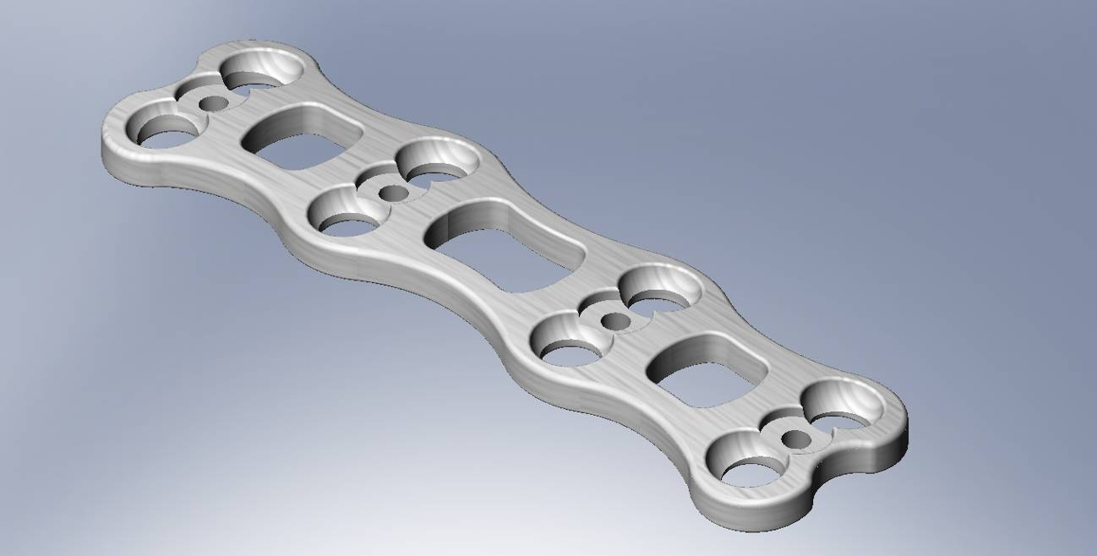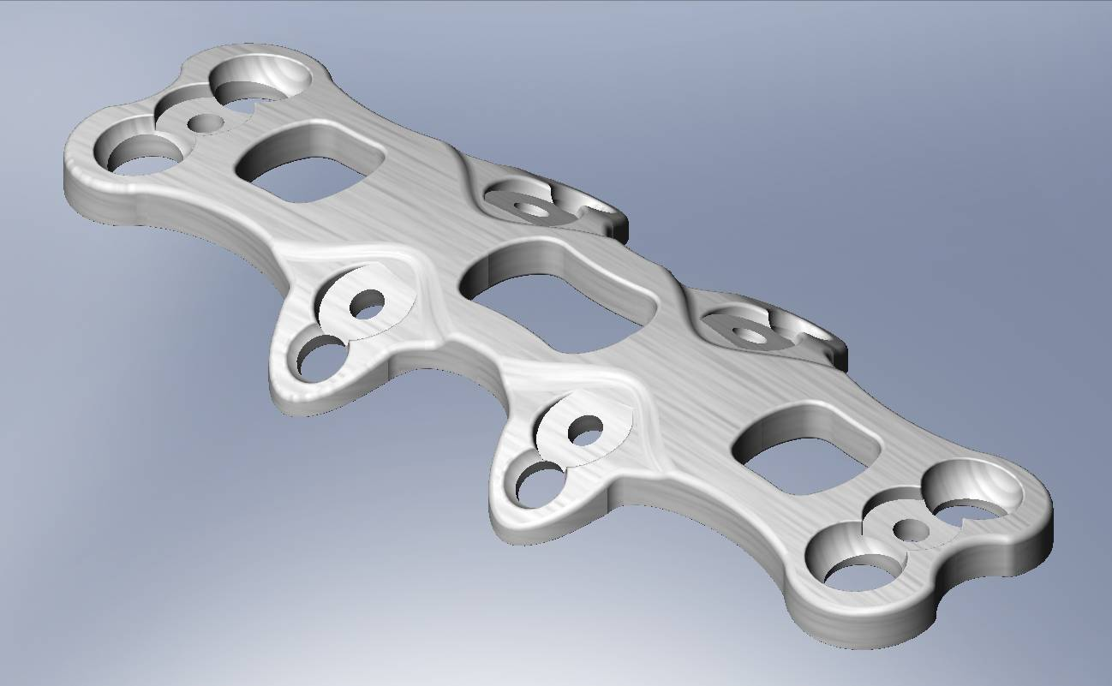Figure 1. Isometric View of the control plate (top) and the final design plate (bottom).
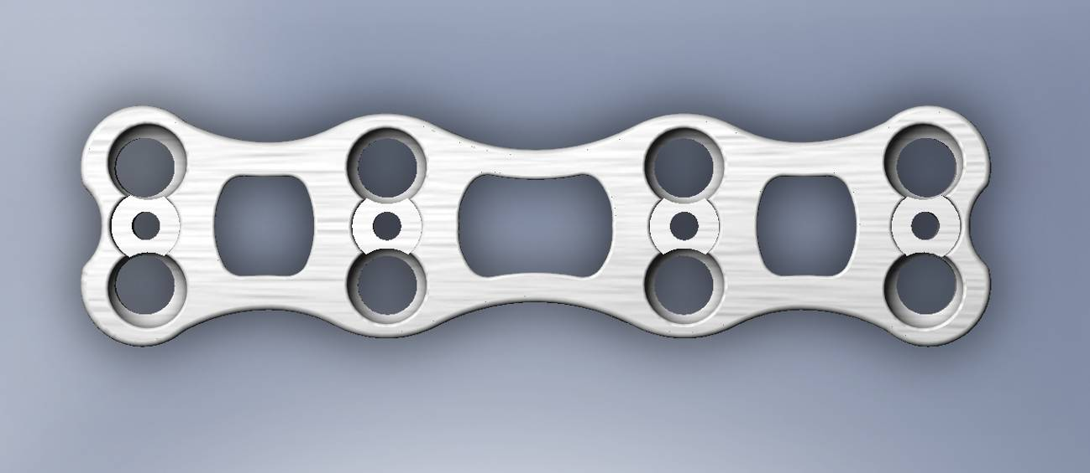
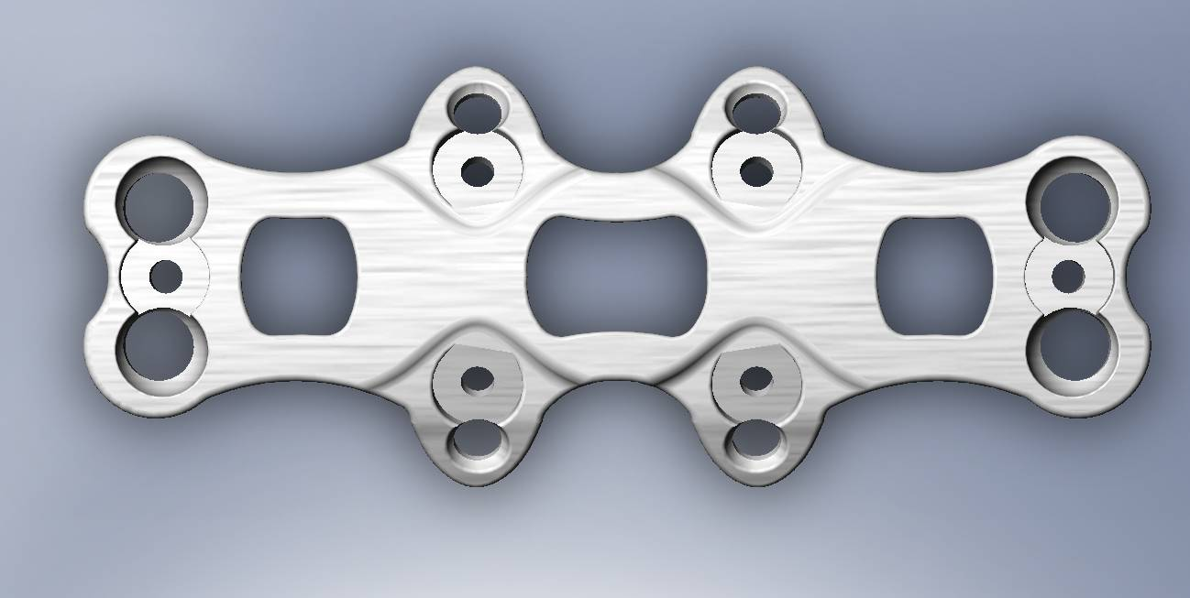
Figure 2. Top View of control plate (top) and final design plate (bottom)
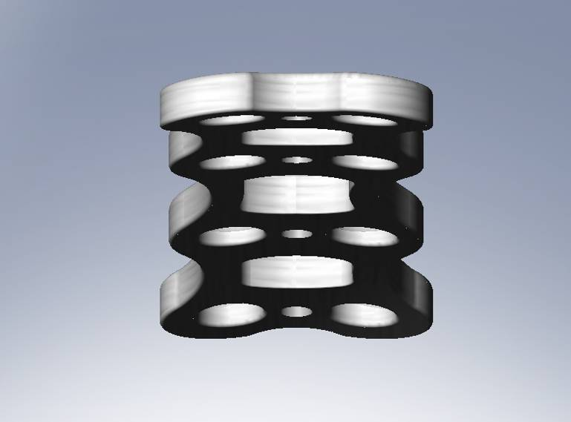
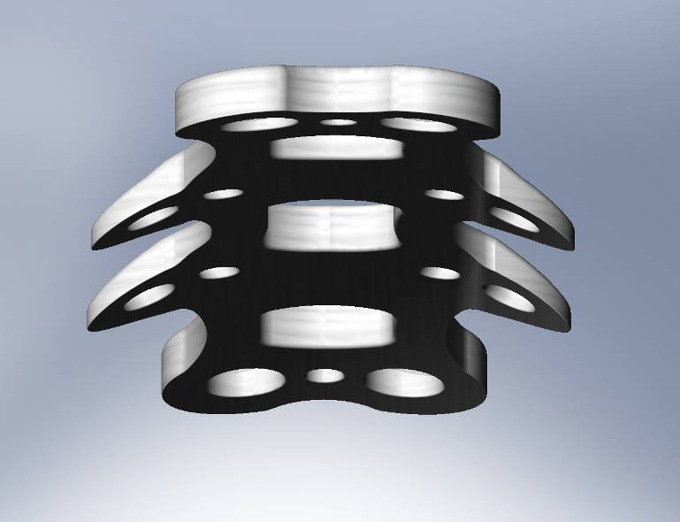
Figure 3. End-on view of control plate (top) and final design plate (bottom)

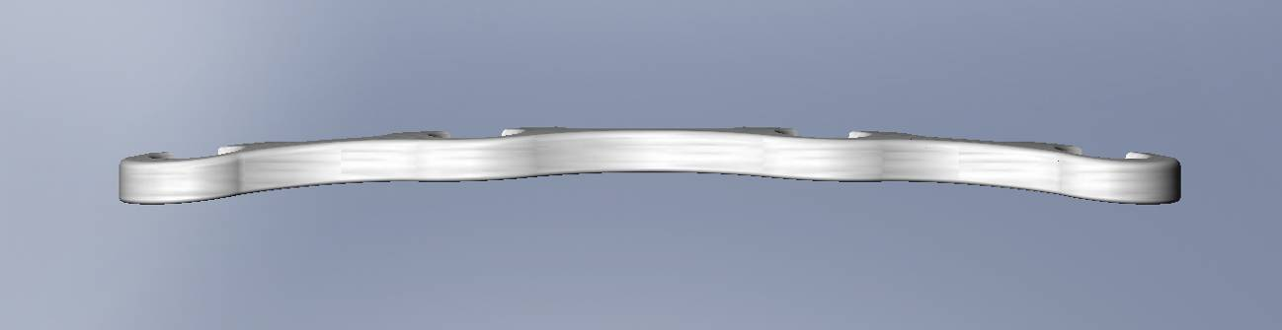
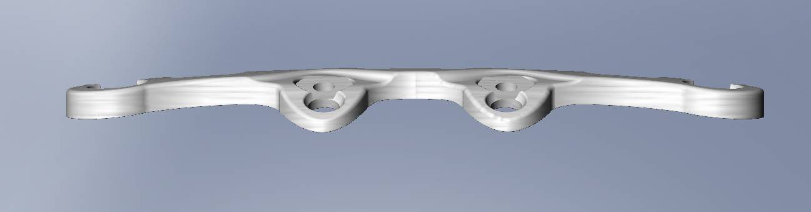
Figure 4. Frontal View of control plate (top) and final plate design (bottom)
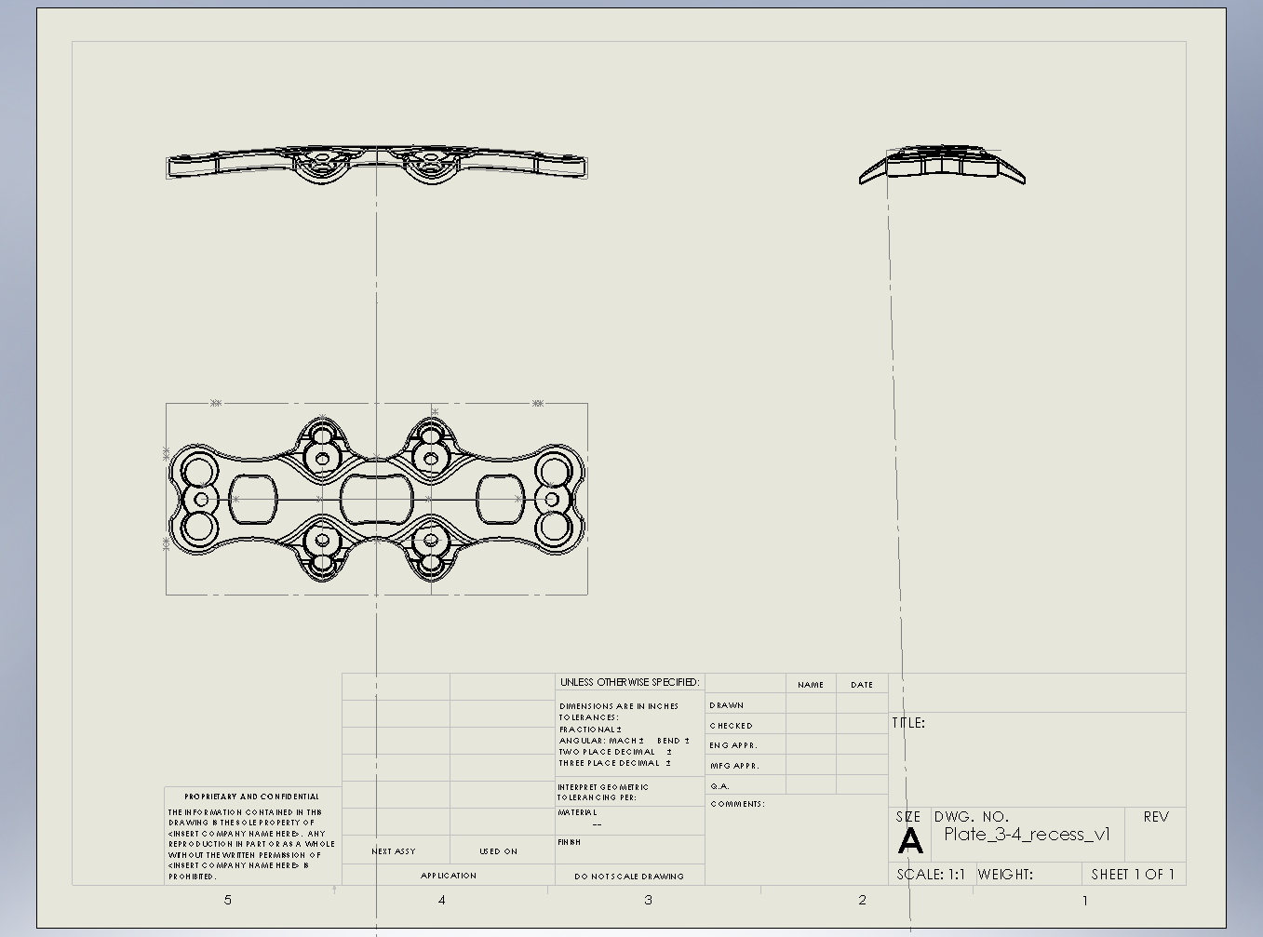
Figure 5. A drawing of the final plate design. Annotations clutter the drawing to the point of indiscernability; the model (.sldprt) is submitted in addition.

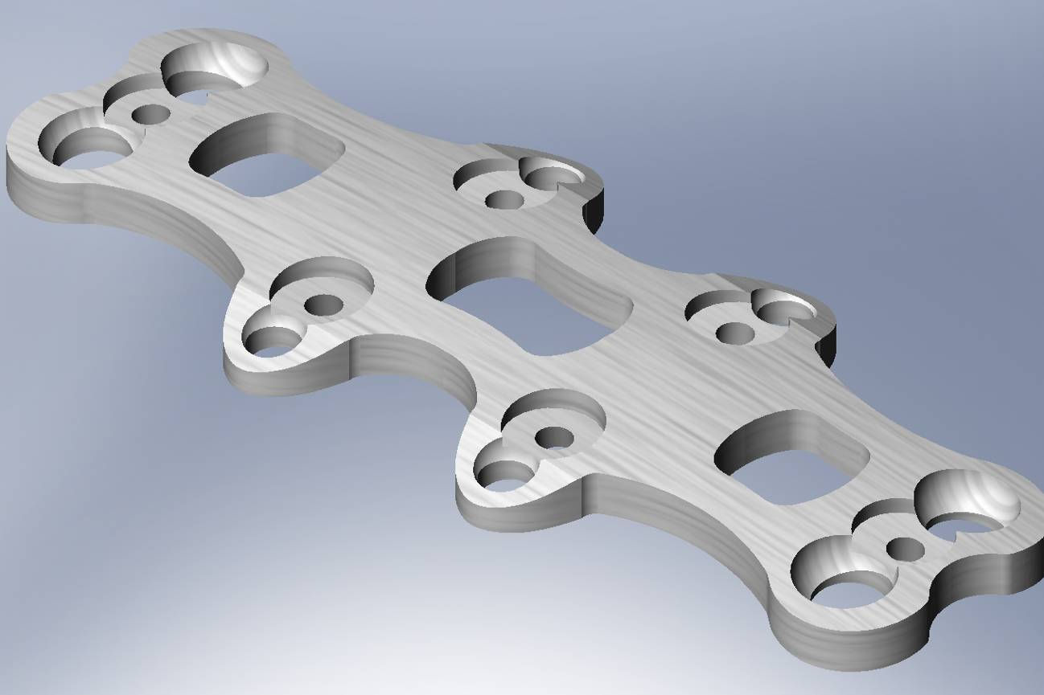
Figure 6. The design plate model that was manufactured in SLA and presented to spine surgeons.
Appendix B – V&V Data

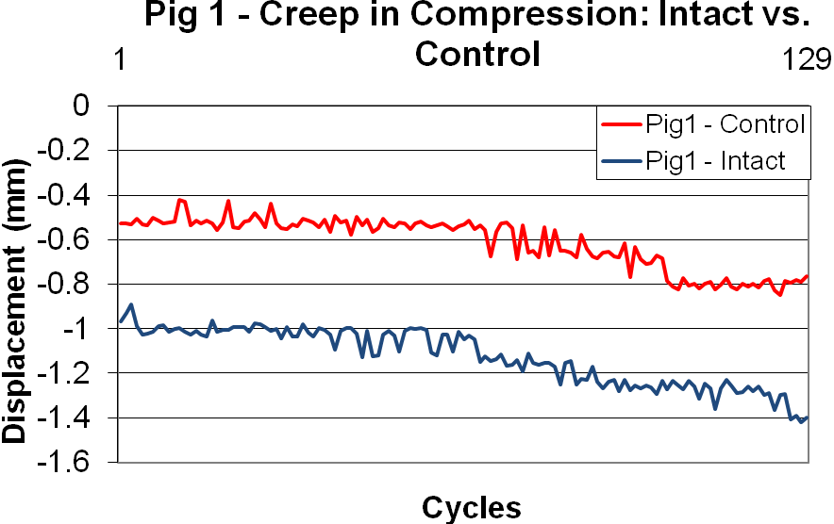
Figure 1. The results for Pig 1 (control plate) in cyclic compression using a 20N load threshold executed on a robot-based spine testing system in a quasi-static manner.
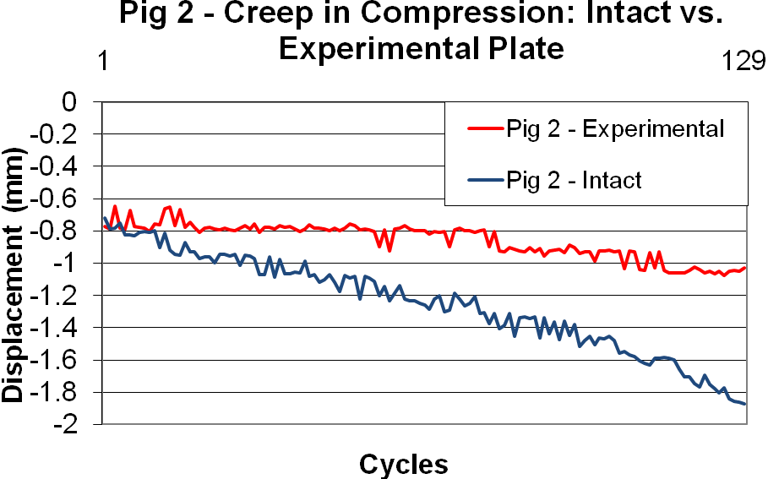
Figure 2. The results for Pig 2 (design plate) in cyclic compression using a 20N load threshold executed on a robot-based spine testing system in a quasi-static manner.

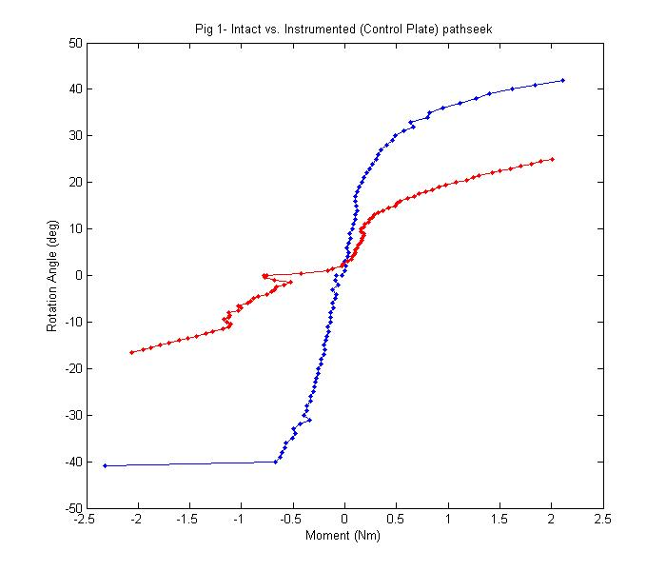
Figure 3. The load-displacement (moment-angle) results in flexion/extension for Pig 1 (control plate) in intact (blue) and instrumented (red) conditions are displayed.
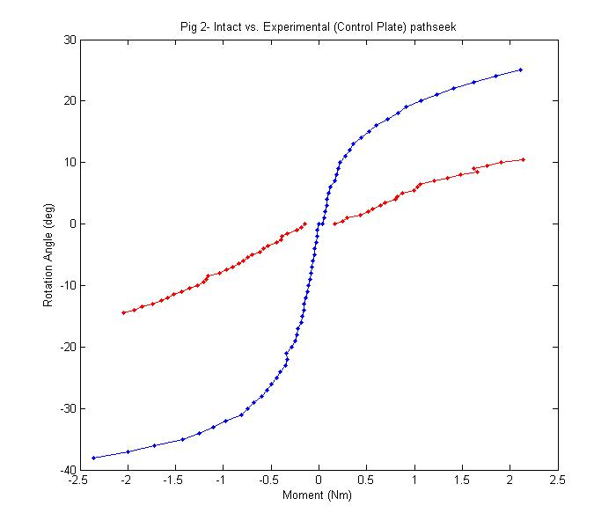
Figure 4. The load-displacement (moment-angle) results in flexion/extension for Pig 2 (design plate) in intact (blue) and instrumented (red) conditions are displayed.
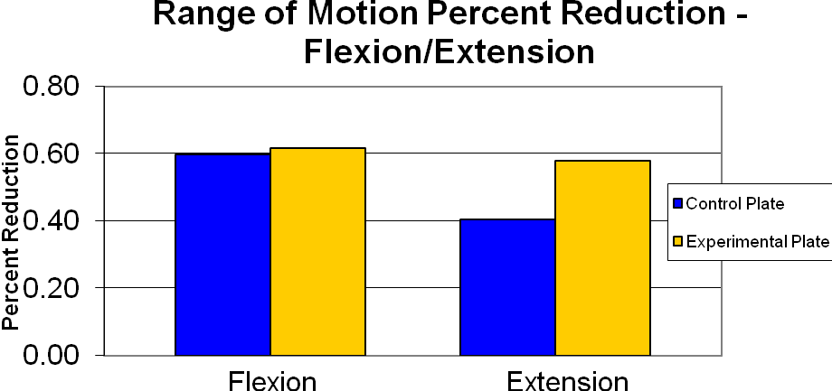
Figure 5. The percent reduction of flexion and extension for each plated specimen are illustrated above.

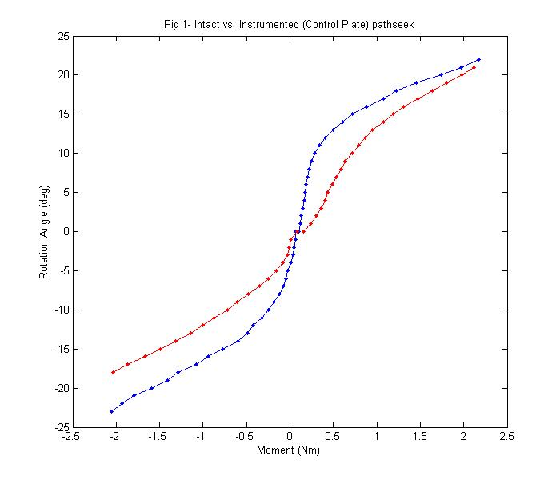
Figure 6. The load-displacement (moment-angle) results in axial rotation for Pig 1 (control plate) in intact (blue) and instrumented (red) conditions are displayed.

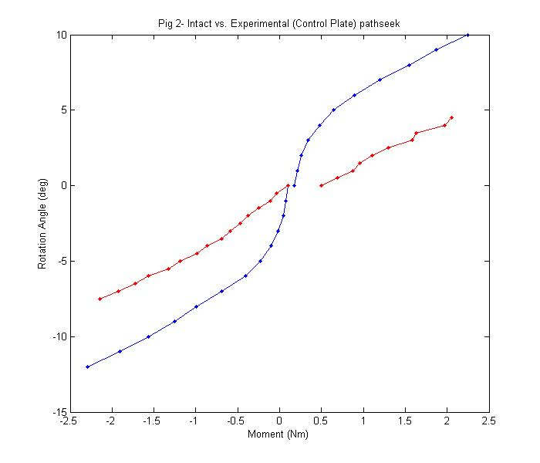
Figure 7. The load-displacement (moment-angle) results in axial rotation for Pig 2 (control plate) in intact (blue) and instrumented (red) conditions are displayed.
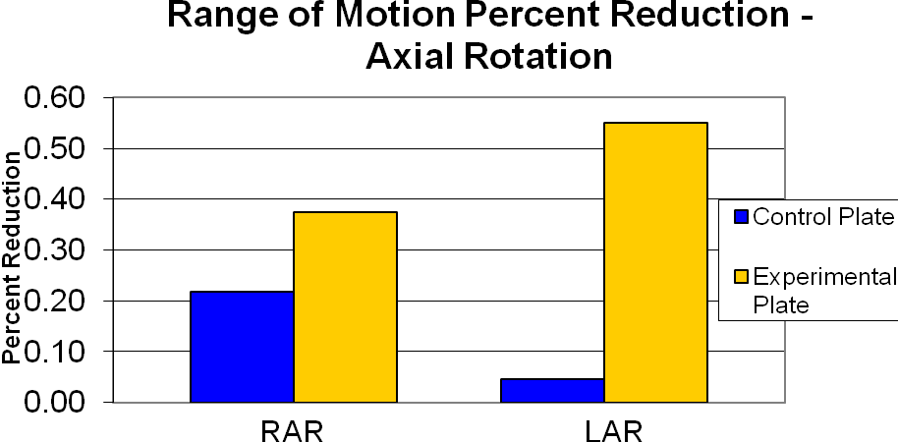
Figure 8. The percent reduction of right (RAR and left (LAR) axial rotation for each plated specimen are illustrated above.

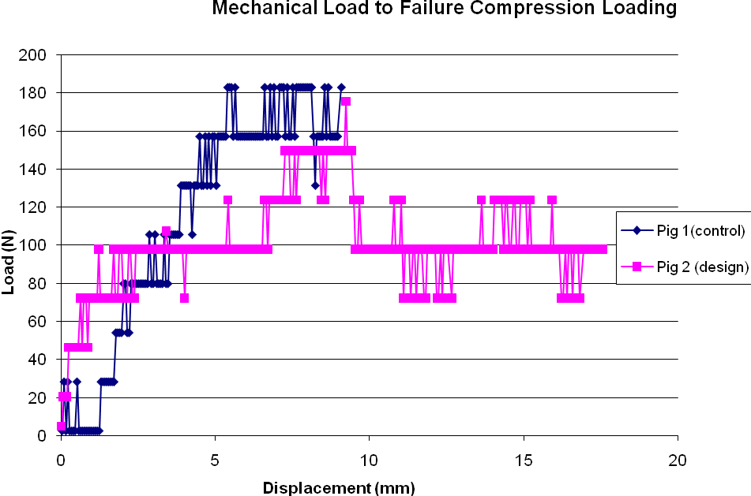
Figure 9. The load-to-failure profiles are shown for the control plate (blue diamonds) and the design plate(pink squares). Failure, in both cases, was the buckling of the metal-coated ceramic plate.
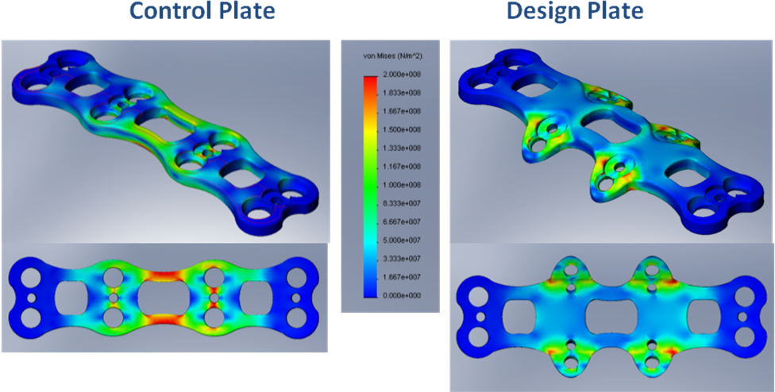
Figure 10. SLArmorTM: Both control and design plates subjected to a 70N distributed load ranging from 0N to 70N normal to the back surface of the plate, simulating the force vertebral bodies exert on anterior plates in extension (2Nm). The von Mises stress scale ranges from 0 Pa to 200 MPa, the yield strength of SLArmorTM.
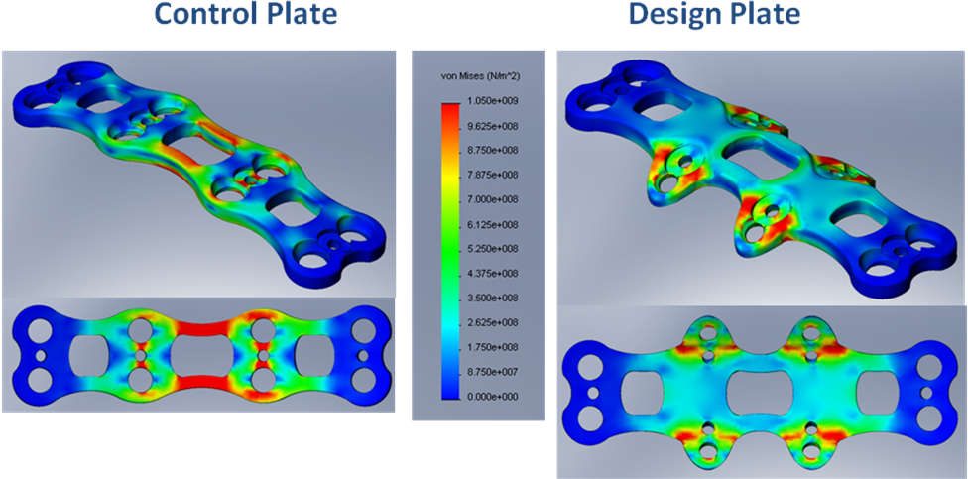
Figure 11. Ti-6Al4V: Both control and design plates subjected to a 500N distributed load ranging from 0N to 500N normal to the back surface of the plate, simulating the force vertebral bodies exert on anterior plates in extension (15Nm). The von Mises stress scale ranges from 0 Pa to 1.05GPa, the yield strength of Ti-6Al4V.
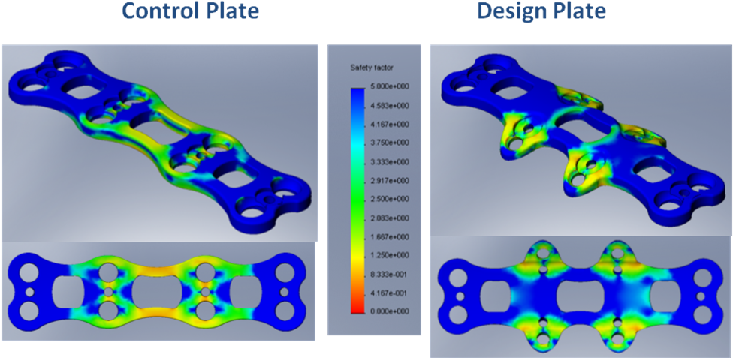
Figure 12. SLArmorTM: Factor of safety (FOS) for 1000 cycles of 70N distributed load on the back side of the plate simulating 2Nm extension. Both the control and design plate results are illustrated. FOS is defined as the ratio between the stress that would exactly cause fatigue failure and the stress Sigma at the considered node.

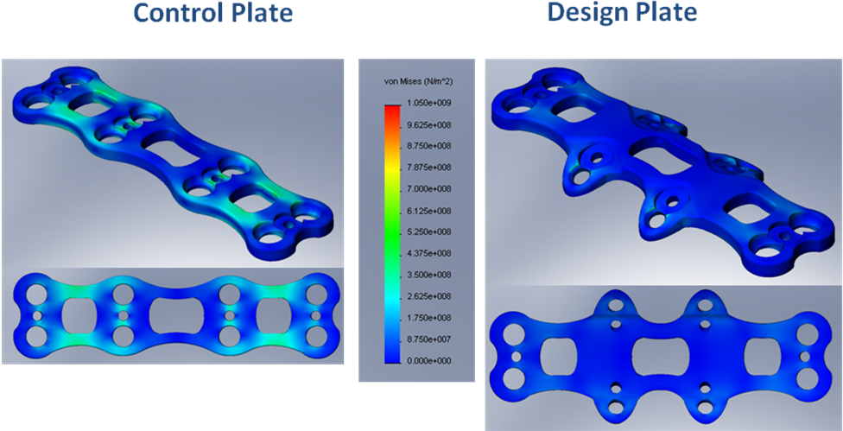
Figure 13. Titanium: Both the control and design plates are subjected to 2.5kN of compression where the loads are distributed evenly at screw locations. The von Mises stress scale ranges from 0 Pa to 1.05GPa, the yield strength of Ti-6Al4V.
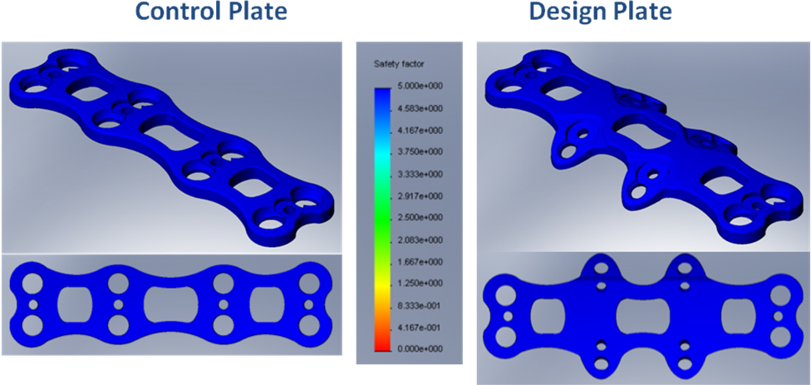
Figure 14. SLArmorTM: Factor of safety (FOS) for 1000 cycles of 20N compression evenly distributed at screw locations. Both the control and design plate results are illustrated. FOS is defined as the ratio between the stress that would exactly cause fatigue failure and the stress Sigma at the considered node.

Table 1. Surgeon evaluation form following the corpectomy procedures performed on porcine specimens.
Topics | much worse than control plate | Much worse than preferred plate | worse than control plate | Worse than preferred plate | about the same as control plate | About the same as preferred plate | better than control plate | Better than preferred plate | much better than control plate | Much better than preferred plate
Plate
Handling |  |  |  |  | o | o
Shape/size |  |  |  |  | o | o
Overall like/dislike of the plate |  |  |  |  | o | o
Surgery
Time |  |  | o | o
Difficulty level |  |  |  |  | o | o
Feasibility |  |  |  |  | o | o
Acquired stability |  |  |  |  |  |  | o | o
Perceived safety |  |  | o | o

